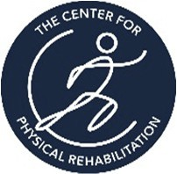


Ergonomic Consultation

County Clerk

1/1/21

Clerk I

1 | P a g e Center For Physical Rehab

Table of Contents
Chapter 1
Company Overview and Profile 3
Chapter 2
Clerk I 5

2 | P a g e Center For Physical Rehab

Chapter 1
Company Overview and Profile

Visit
Kermit the Frog, County Risk Manager, contacted The Center for Physical
Rehabilitation requesting information about injury risk assessment, management and
prevention for a specific role within the county clerk’s office. The visit occurred early into
the work day for the Clerk I role. This visit was to spend a brief time to understand the
role and functions of the Clerk I and to provide feedback about ergonomic controls, safe
lifting techniques and potential injury prevention recommendations. During this visit the
evaluator was able to take limit photos and some video of the client who had complaints
of low back discomfort as well as view the main workloads and spaces the Clerk I
spends their time in. It was explained that the employer and the client being observed were interested in injury prevention recommendations and tips to improve their
workstation setup.

Injuries
OSHA 300 logs were not evaluated at this consultation and specific injury data
relative to these roles was not gathered, but it was reported by the employer and
confirmed by the observed employee that the primary musculoskeletal discomforts have
been in the low back region. This has led the evaluator to calculate lifting operations for
the Clerk I role.

3 | P a g e Center For Physical Rehab

Company Overview and Profile Recommendations

1. The County Clerk I serves a vital role in providing timely and necessary
documents to the court in support of current and ongoing cases that are pursuing
resolution. The Clerk I position would benefit from direction in safe lifting
techniques, injury prevention and ergonomic guidance for work station setup.
The focus of this program would be on education, early recognition and
prevention of signs and symptoms and to ensure that these do not turn into
recordable injuries. This program would consist of pre-shift and/or post-break
warm up exercises conducted by a trained employee along with educational
opportunities for employees and training on proper lifting techniques for newly
hired staff. This could be accomplished with direct training of several office staff
on safe lifting techniques and benefits of proper work station setup and exercise
before starting a shift.

4 | P a g e Center For Physical Rehab

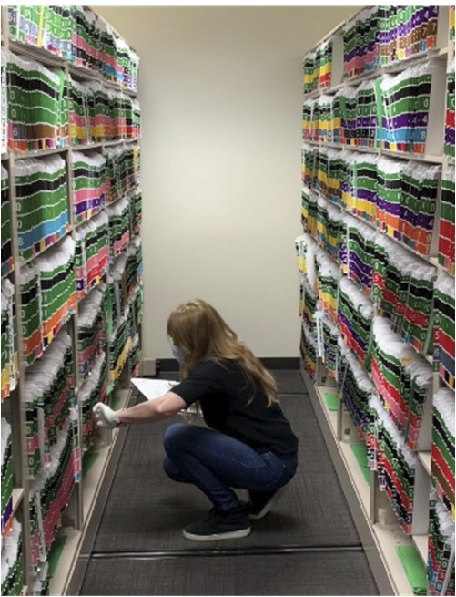
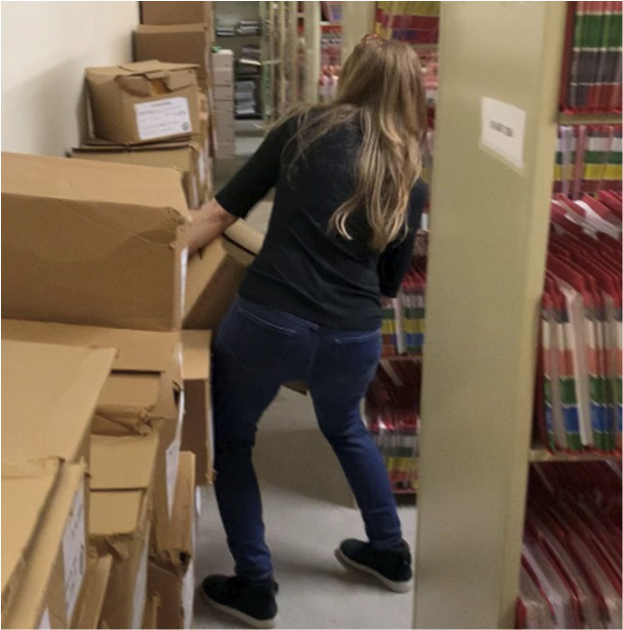
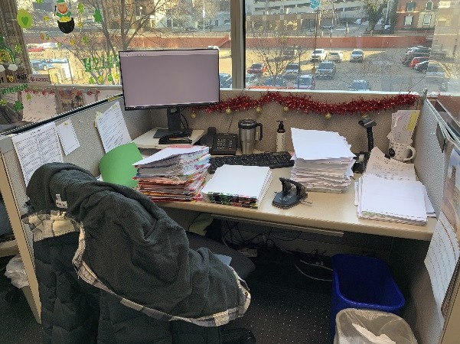


Chapter 2
Clerk I

Work Objective:
The Clerk I role is in place to provide general clerical support for the department.
In providing support to the department, the Clerk I is tasked with sorting and filing
records for the department in the designated areas and systems. This includes their
main office on the 2nd floor as well as their larger storage area on the 5th floor. A large
part of their role also consists of delivering and retrieving files from multiple other offices
and floors throughout the building. Several images are pictured above and show
positions and work areas that are common for an employee in this role. It was explained
by the employee that the work is self-paced, however, all of the needed records for the
day must be properly delivered and filed before their shift is completed.

5 | P a g e Center For Physical Rehab

Work Schedule:
This is a single shift job with clerks working 8 hours a day in this role. The current
structure of this role does not include any rotation of tasks or roles. If an employee is
absent it is a team effort to complete the filing and deliveries for them. It is understood
that this role operates per OSHA guidance and Michigan Labor Laws in terms of breaks.
The issues that raise concern with this position are the heavy lifting of cases of records
and workstation setup.

Work Method:

The essential process for the Clerk I includes performing record filing and
deliveries throughout the majority of the day. This includes retrieving files from a shelf
storage system and pushing a wire frame cart to multiple floors for delivery of records.
The heavy tasks of moving records in banker’s boxes have historically been saved for
the end of the day in the 5th floor storage area. This generally takes up the last 1-2
hours of the day.
The employee’s computer work station was also assessed. It was noted that the computer monitor was moved to the far left corner and further than the recommended distance of 24” from the employee. The monitor was positioned on top of a lift and
allowed the employee to keep her cervical spine in a neutral posture, indicating the height is at an acceptable position. It is recommended that monitors be placed directly in front of the employee at a maximum distance of 24”. In this situation the employee should move her monitor to the center of her work station.
The keyboard was pushed back to the middle of the work surface which causes
the employee to extend her elbows and reach forward to be able to key or type with the
keyboard. The general recommendation is that the keyboard be placed within 13”-17” of
their body allowing for the elbows to bent, shoulder to be in a neutral position and lower
arms to be supported by armrests of the chair. The work station would benefit from
keyboard tray to allow for easy access and desk space to place records and files as
needed.

6 | P a g e Center For Physical Rehab

The employees chair had several adjustable features and was noted as being a
newer chair. The chair was positioned with the seat pan directly against the back of the
employee’s legs and the hip and knee at the same level. The chair did not have
additional lumbar support. The employee may need or request additional support if
modifications do not aid in reducing low back discomfort. The chair was adjusted so that
there is about 3” from the seat pan to the back of the leg, the height was raised so that
the hip is slightly above the knee and the feet were able to remain flat on the floor.

Task Analysis:
An analysis was performed for the Clerk I role. The Calculator for analyzing lifting operations provided by the Department of Labor and Industries as well as Threshold Limit Values (Lifting TLV) were used to assess the lifting demands of this role. These evaluation tools were used because there were complaints of increased low back
discomfort after lifting tasks were completed.

Position 1: Clerk I

Tools and Equipment Used:
Tools and equipment that were noted in this position include but are not limited to the following:

A wire mail cart with casters and gloves for gripping records

Lifting Assessment
The Department of Labor and Industries Calculator for lifting operations and the Lifting TLV revealed that the lifting tasks of this job may be hazardous by indicating the safe amount to lift from the distances, number of lifts per minute and for the duration per day would be between 34 - 42lbs. The areas of concern that were discovered include the maximum weight that the banker boxes are able to hold (approximately 45lbs), the number of times the boxes need to be moved, and the repetitive bending and stooping that is performed throughout the day.

7 | P a g e Center For Physical Rehab

Recommendations:

1. The placement of the computer monitor should be 20-30” from the eyes and
directly in front. This helps to decrease strain on the eyes and prolonged cervical rotation in the neck. The monitor should remain at the current height or a height that is allows the top 1/3 of the monitor to be at eye level.
2. The keyboard should be place 13”-17” from the body allowing the arms to be
supported by the arm rests and shoulder to be in a neutral position.
3. Seating should be adjusted to allow for 2-3” from the seat pan to the back of the
leg, the hip should be no lower than the knee and feet should rest flat on the floor
of on a support foot rest. The arm rests should allow for the arms to be supported
without leaning to reach them and the upper arm should be perpendicular to the
floor.
4. The lighting from the window may cause increased strain on the eyes especially
if it is brighter than the screen monitor. Installing or making use of ample shading
will decrease eye strain and the potential for tension in the head and neck.
5. Education on proper lifting, bending and stooping techniques should be reviewed
with employees to ensure safe moving patterns and to avoid the risk injury.
6. Pre-shift and/or Post-Break warm-up exercises should be introduced to prepare
employees for the physical aspect of the job. These exercise aid the body in
increased blood flow, reduced muscle fatigue, practiced safe lifting patterns for
reduced risk of injury.
7. The use of boxes/cases with durable and proper lifting handles will make moving
and lifting cases of records easier.
8. Using a spring supported cart that lowers with increased weight will make
temporarily moving full boxes easier and allow for decreased lifting distance when moving them back to their respective places.
9. Currently, employees save the heavier moving of cases on the 5th floor for the
last part of the day. It is recommended to have a rotation of heavier lifting. This would allow some of the lifting tasks to be completed before the employee has already been fatigued from the normal tasks of the day.

8 | P a g e Center For Physical Rehab

