The Center for Physical Rehabilitation - Cascade
5060 Cascade Rd. Suite A Grand Rapids, MI 49546 (p) 616-954-0950
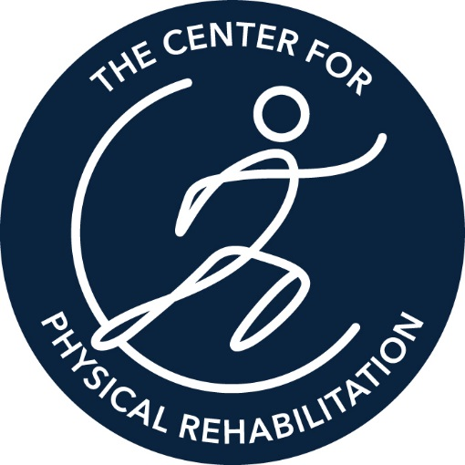
www.pt-cpr.com

Client: Kermit Construction
Occupation: Construction
Job Title: Construction Worker
Date of Analysis: 7/1/2019

Job Demands Analysis
Address: 601 First St NW Phone Number: 616 555 1800 Was job videotaped?: No

Job Description
Construction jobs require vigorous physical activity in every craft. The construction environment may be hot, cold, wet, dry, dusty, windy, dirty or muddy. The terrain of the construction site may be rough and uneven. Construction equipment of all sizes from pickup trucks to heavy equipment etc. may be present on the job site at any time. Work may be done in equipment, on the ground, in trenches, in confined spaces, or at heights, depending on the project.

Duties and Responsibilities
The essential functions and job duties of each craft vary, but all construction workers may be required to routinely perform a wide variety of tasks involving standing, walking, lifting, carrying, climbing, stooping, kneeling, etc.

Listed below are some of the essential functions that workers on a construction site may be required to perform:

- Climbing up and down ladders, machinery, and other objects.
- Maintain balance in all situations.
- Reach for hold handles and operator manipulated objects and materials.
- Push, pull and frequently carry objects as tools, materials and equipment weighing up to 60 pounds.
- Stoop, kneel, crouch and crawl.
- Stand and walk for long periods of time.
- Coordinate movement of eyes, hands, fingers, and feet.
- Work at different heights.
- See and hear well with or without correction. To avoid safety hazards to themselves and others.
- Distinguish colors.
- Utilize depth perception.
- Fuel, change oil, add fluids, and lubricate machinery.
- Do paper work associated with the job and time card.
- Operate Machinery.

Qualifications
- Must have valid driver license.
- Be at least 18 years of age.
- High school diploma.
- Ability to do physical labor and other strenuous physical tasks.
- Ability to work in all weather.
- Workers must be punctual and reliable.
- Must have experience as a general laborer in the construction industry.

Overall Physical Demands
Material Handling |  | Occasional | Frequent
Bilateral Lifting |  |  | 60 Pounds
Bilateral Carry |  |  | 60 Pounds
Unilateral Carry |  |  | 25 Pounds
Pushing |  |  | 60 Pounds
Pulling |  |  | 60 Pounds
Repetitive Functional Activities | Never | Occasional | Frequent
Above Shoulder Reach |  |  | X
Bending |  |  | X
Forward Reach |  |  | X
Ladder |  |  | X
Squatting |  |  | X
Fine Motor Coordination |  | X
Static Balance |  |  | X
Sustained Squatting |  | X
Dynamic Balance |  |  | X
Gross Motor Coordination |  |  | X
Repetitive Kneeling |  |  | X
Sustained Kneeling |  | X
Simple Grasp |  | X
Firm Grasp |  |  | X
Pinching |  | X

Essential Job Function 1 Build Up - Tasks involved with building, repairing or enhancing a structure
Essential Job Function 2 Demolition - Deconstruct structures by pulling, pushing and swinging a sledge mall.

Environmental Conditions
Environmental conditions noted include the employees working in locations that include Indoors, Outdoors, Ground Vehicle, Excavation, High Exposed Places and Below Ground. Exposures noted include High Noise, Dust, Fumes, Odor, Smoke, Vibration, Slippery Surfaces, Unprotected Heights, Moving Machinery, Heat Source and Electricity.

Personal Protective Equipment
Personal Protective Equipment associated with eye and face protection include Safety Glasses. Personal Protective Equipment associated with head protection include Hard Hat.
Personal Protective Equipment associated with hand and arm protection include Protective Gloves, Leather Gloves and Canvas Gloves.
Personal Protective Equipment associated with foot and leg protection include Toe Guards and Safety Shoes. Personal Protective Equipment associated with hearing protection include Pre-Formed Earplugs.

Vocational Information
The physical demands for this evaluation were gathered from a Job Description.

If I can be of assistance in interpreting the aforementioned data regarding this Job Demands Analysis, please feel free to contact me at:

The Center for Physical Rehabilitation - Cascade
5060 Cascade Rd. Suite A Grand Rapids, MI 49546 616-954-0950
www.pt-cpr.com
Electronically Signed/Authenticated by
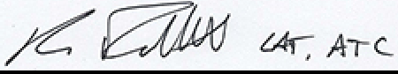
Ken D Follett, AT, ATC | Date: 07/16/2019 01:08:06 PM CST

